# Author: Bedemariam Degef

# Date; January 29, 2019

# Python State, Capital, flower and Bird List Application Test Case

# Python Math Set Application Test Case

|  |  |  |  |  |
| --- | --- | --- | --- | --- |
| Test Case | Input | Expected Output | Actual Output | Pass? |
| 1a | 1 | States in alphabetical order along with capital and flower | Figure 1. Test Case 1a Execution results | Yes |
| 1b | @#! | Please enter an integer between 1 and 6 to make your selection | Please enter an integer between 1 and 6 to make your selection | Yes |
| 1c | 2  Virginia | CAPITAL:Richmond BIRD:Cardinal | CAPITAL:Richmond BIRD:Cardinal | Yes |
| 1d | 2  south dakota | CAPITAL:Pierre BIRD:Ring-necked Pheasant | CAPITAL:Pierre BIRD:Ring-necked Pheasant | Yes |
| 1e | 2  NORTH CAROLINA | CAPITAL:Raleigh BIRD:Cardinal | CAPITAL:Raleigh BIRD:Cardinal | Yes |
| 1f | 2  Happy Day | Happy Day is not a state | Happy Day is not a state | Yes |
| 1g | 3  Texas  Nemo | The name has been changed now it reads BIRD:Nemo | The name has been changed now it reads BIRD:Nemo | Yes |
| 1h | 3  2389 | 2389 is not a state | 2389 is not a state | Yes |
| 1i | 4 | Exit program | Exit program | Yes |

Figure 1. Test Case 1a Execution results

Figure 2. Test Case 1b Execution results

Figure 3. Test Case 1c Execution results

Figure 4. Test Case 1d Execution results

Figure 5. Test Case 1e Execution results

Figure 6. Test Case 1f Execution results

Figure 7. Test Case 1g Execution results

Figure 8. Test Case 1h Execution results

Figure 9. Test Case 1i Execution results

|  |  |  |  |  |
| --- | --- | --- | --- | --- |
| Test Case | Input | Expected Output | Actual Output | Pass? |
| 2a | 1 | Square and Cube for Integers ranging from 1 to 100 | Square and Cube for Integers ranging from 1 to 100 | Yes |
| 2b | $(@#two | Please enter an integer between 1 and 6 to make your selection | Please enter an integer between 1 and 6 to make your selection | Yes |
| 2c | 2  79 | 79 is not in either set | 79 is not in either set | Yes |
| 2d | 2  81 | 81 is found in the set  The square of 81 is 6561  The cube of 81 is 531441 | 81 is found in the set  The square of 81 is 6561  The cube of 81 is 531441 | Yes |
| 2e | 3 | The union of the sets | The union of the sets | Yes |
| 2f | 4 | The intersection of the sets | The intersection of the sets | Yes |
| 2g | 5 | The difference of the sets | The difference of the sets | Yes |
| 2h | 6 | Exit program | Exit program | Yes |

Figure 10. Test Case 2a Execution results

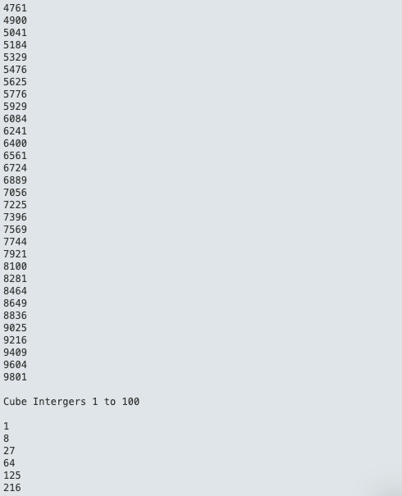

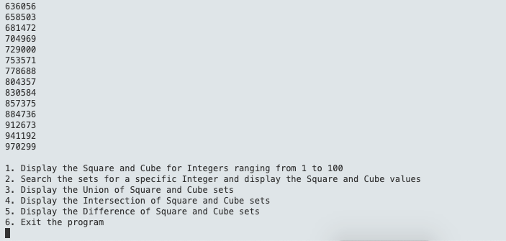

Figure 11. Test Case 2b Execution results

Figure 12. Test Case 2c Execution results

Figure 13. Test Case 2d Execution results

Figure 14. Test Case 2e Execution results

Figure 15. Test Case 2f Execution results

Figure 16. Test Case 2g Execution results

Figure 17. Test Case 2h Execution results

